Week Ending: |  | DAY: |  |  |  | Subject: Creative Arts
Duration: 60mins per lesson |  |  |  |  |  | Strand: Visual Arts
Class: B5 |  | Class Size: |  |  |  | Sub Strand: Appreciating and Appraising
Content Standard:  Demonstrate understanding of how to generate own ideas for artistic expressions on the people, based on their history and culture |  |  |  |  | Indicator:  B5 1.4.6.3 /B5 1.4.7.3 develop guidelines for appreciating and appraising own and others’ visual artworks that reflect the topical issues in Africa |  |  |  | Lesson:  1 OF 1
Performance Indicator:  - Learners can develop guidelines for appreciating and appraising own and others’ visual artworks that reflect the topical issues in Africa. |  |  |  |  |  |  | Core Competencies:  Decision Making Creativity, Innovation Communication
Teaching/ Learning Resources |  |  | Photos, videos, art paper, colors and traditional art tools
References: Creative Arts Curriculum Pg. 75
DAYS | PHASE 1: STARTER |  |  | PHASE 2: MAIN |  |  |  | PHASE 3: REFLECTION
 | Have learners sing songs in relation to the lesson.  - Would you love to sing more songs?  - What words did you hear in the song?  - Write some of the words you heard.  Share the performance indicators and introduce the lesson. |  |  | Appreciating in art is the ability of people to look at a work of art and understand how the work was made.  Explain to learners the guidelines and have them agree to it.  - Description of the work: this stage involves describing what the work is made of, size of the work and materials used.  - The subject matter: this stage talks about the meaning of the work.  - Appraisal: this stage talks of the use of the artwork.  - Experience to share: this stage talks about the design process |  |  |  | Use questions to review their understanding of the lesson  Ask learners to summarize what they have learnt  Learners to read and spell the key words on the board
 | Have learners sing songs in relation to the lesson.  - Would you love to sing more songs?  - What words did you hear in the song?  - Write some of the words you heard.  Share the performance indicators and introduce the lesson. |  |  | Using the steps in appreciating and appraisal, guide learners to write a note on a previous artwork produced or performed in class.  E.g. an artwork produced by Ibrahim Mahama  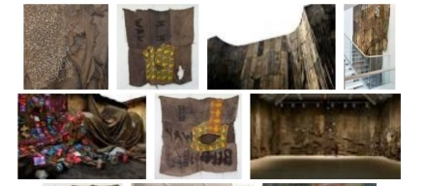  - Description of the work: the artwork are made from old jute bags by stitching them together  - The subject matter: His art seeks to interpret the global movement of goods.  - Appraisal: it can be used for decoration.  - Experience to share: talk about how the artwork is done. |  |  |  | Use questions to review their understanding of the lesson  Ask learners to summarize what they have learnt

