Week Ending: |  |  |  |  |  | Subject: History
Duration: 60mins per lesson |  |  |  |  |  | Strand: My Country Ghana
Class: B2 |  |  | Class Size: |  |  | Sub Strand: Some Selected Individuals
Content Standard:  B2.2.5.1.1 Exhibit understanding of Ghanaian women who have contributed significantly to Ghana’s development |  |  |  | Indicator:  B2.2.5.1.1. Identify Ghanaian women who have made significant contributions to national development |  |  |  | Lesson:  1 OF 1
Performance Indicator:  Learners can identify Ghanaian women who have made significant contributions to national development. |  |  |  |  | Core Competencies:  As learners use evidence to explore the chronology of events, they enhance their global citizenship, and digital literacy
Resources |  | Pictures of some outstanding Entrepreneurs in Ghana
Key words |  | Editor, national university, pilot, Air Force, wings, journalist, politicians, tertiary, government, ICT,
References: History Curriculum Pg. 12
DAYS | PHASE 1: STARTER |  |  | PHASE 2: MAIN |  |  | PHASE 3: REFLECTION
TUES | Paste a picture of the personality to be studied.  Have learners talk about the picture.  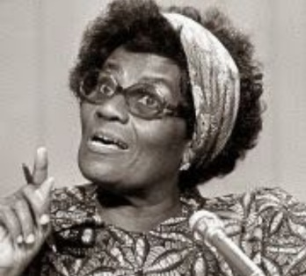  Have learners match pictures of women to their careers. |  |  | Let learners identify and talk about Ghanaian women who have made significant contributions to national development.  Have them match pictures of women to their achievements.  Guide learners to name some outstanding women in the history of Ghana.  E.g. Mrs Charity Zormelo-Fiawoo.  Through class discussion, guide learners to discuss the history of Mrs Charity Zormelo-Fiawoo.  MRS CHARITY ZORMELO-FIAWOO  Mrs Charity Zormelo-Fiawoo was the first woman graduate from the Gold Coast, and the first woman from English speaking West Africa to earn a B.S degree. Mrs. Charity Zormelo-Fiawoo is a Ewe born in Keta, Ghana, was the daughter of Godfred Nyavor Zormelo, a former north German mission employee and fishing business proprietor, and Patience Abolitsi Dzokotoe. In 1930 she graduated from high school in Bordentown, new jersey, and used a scholarship to enroll in Home Economics at Hampton institute where she graduated in 1934.  Learners tell the class parts of the history they enjoyed. They retell the history in their own words.  Assessment  Who was Mrs Charity Zormelo-Fiawoo? |  |  | Ask learners series of questions to review their understanding of the lesson  Home Work  Ask learners to speak to women at home and in their communities about their challenges, what life was like in the past for women, and so on  Next lesson: Identify Ghanaian women who have made significant contributions to national development
 | Paste a picture of the personality to be studied.  Have learners talk about the picture.  Have learners match pictures of women to their careers. |  |  | Brainstorm learners to talk on different job careers they know of.  Learners in groups, describe the job roles of the various careers identified.  In a class discussion guide learners to identify the names of women who have/is occupying such positions in the country.  Allow learners time to investigate more about the lives and achievements of these people.  Assessment  Think pair-share-activity: Individual learners identify a woman who they admire most in the community.  They choose partners and discuss the reasons for their choice. |  |  | Ask learners series of questions to review their understanding of the lesson  Home Work  Ask learners to speak to women at home and in their communities about their challenges, what life was like in the past for women, and so on  Announce the next indicator  In our next lesson, we will identify more Ghanaian women who have made significant contributions to national development.

