Week Ending: |  |  |  |  |  | Subject: Science
Duration: |  |  |  |  |  | Strand: Forces And Energy
Class: B3 |  | Class Size: |  |  |  | Sub Strand: Forces And Movements
Content Standard:  B3.4.3.2 Recognize some simple machines used for making work easier, analyze their advantages and know their uses. e.g. levers, inclined planes and pulleys |  |  |  | Indicator:  B3.4.3.2.1. demonstrate how to maintain and care for simple machines |  |  | Lesson:  1 OF 1
Performance Indicator:  - Learners can demonstrate how to maintain and care for simple machines |  |  |  |  | Core Competencies:  Problem Solving skills; Critical Thinking; Justification of Ideas
Teaching/ Learning Resources |  |  | Pictures / charts / drawings of simple machines, oil, grease, clean cloth
New words | Simple machines, care
References: Science Curriculum Pg. 59
DAYS | PHASE 1: STARTER | PHASE 2: MAIN | PHASE 3: REFLECTION
 | Engage learners in groups to say, write or draw any simple machine and give its use.  Take feedback from learners.  Share performance indicators and introduce the lesson. | Display simple machines for learners to observe and identify in groups.  Show learners pictures of simple machines.  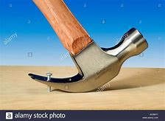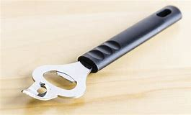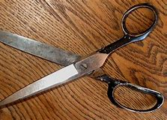  Engage learners to talk about their uses in groups.  Assessment  State the uses of the hammer, scissors and bottle opener.  Mention 5 simple machines you use at home. | Ask learners questions to review their understanding of the lesson.  Have learners write 3 facts to summarize the lesson.  Homework  - State the uses of the hammer, scissors and bottle opener.  - Mention 5 simple machines you use at home.
 | Engage learners in a short conversation and ask;  - What makes work easier and faster in our homes, schools and work places?  - What can we do to increase the life span of machines?  Share performance indicators and introduce the lesson. | Learners in groups research to come out with ways of caring for simple machines.  They present their findings to the class.  - How do you care for your machines at home?  - Demonstrate how you maintain your machines at home?  Engage learners to mention how simple machines are maintained and stored in their homes.  - Add and test lubricants frequently  - check for signs of wear  - always keep machines clean and dry  - have a maintenance and repair schedule, and keep good records  Let learners undertake basic maintenance practices such as oiling, removing dirt, washing and using them for correct purposes.  Learners should share their views about the activities. | Engage learners to mention how simple machines are maintained in their homes, schools and work places.  Write some of their answers on the board.  Homework  Have learners to say 5 words to express their thoughts of the lesson.
 | Engage learners in a short conversation and ask;  - What makes work easier and faster in our homes, schools and work places?  - What can we do to increase the life span of machines?  Share performance indicators and introduce the lesson. | Learners in groups research to come out with ways of caring for simple machines.  They present their findings to the class.  - How do you care for your machines at home?  - Demonstrate how you maintain your machines at home?  Engage learners to mention how simple machines are maintained and stored in their homes.  - Add and test lubricants frequently  - check for signs of wear  - always keep machines clean and dry  - have a maintenance and repair schedule, and keep good records  Let learners undertake basic maintenance practices such as oiling, removing dirt, washing and using them for correct purposes.  Learners should share their views about the activities. | Engage learners to mention how simple machines are maintained in their homes, schools and work places.  Write some of their answers on the board.  Homework  Have learners to say 5 words to express their thoughts of the lesson.  We shall describe varied ways of keeping the environment clean in our next lesson

