Week Ending: |  | DAY: |  |  |  | Subject: OWOP
Duration: 60mins per lesson |  |  |  |  |  | Strand: Our Beliefs And Values
Class: B6 |  | Class Size: |  |  |  | Sub Strand: Basic Human Rights
Content Standard:  B6.3.3.1. Demonstrate understanding of fundamental human rights |  |  |  | Indicator:  B6.3.3.1.1. Identify sources of help |  |  | Lesson:  1 OF 1
Performance Indicator:  Learners can identify sources of help |  |  |  |  | Core Competencies:  Communication and Collaboration Critical Thinking
Teaching/ Learning Resources |  |  | Pictures, Charts, Video Clips
New words
References: OWOP Curriculum Pg. 54
DAY | PHASE 1: STARTER | PHASE 2: MAIN | PHASE 3: PLENARY
 | Activate the previous knowledge of the learners by making them answer questions on the previous lesson.  Engage learners to play games and sing songs to begin the lesson | Learners discuss how to speak e.g. speak out and not keep quiet over an abuse  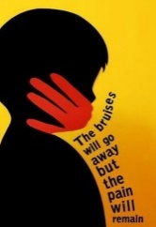  Learners create posters speaking against child abuse and also show where to go for help in case of abuse. | Use questions to review their understanding of the lesson  Ask learners to summarize what they have learnt
 | Activate the previous knowledge of the learners by making them answer questions on the previous lesson.  Engage learners to play games and sing songs to begin the lesson | Learners discuss how to speak e.g. speak out and not keep quiet over an abuse  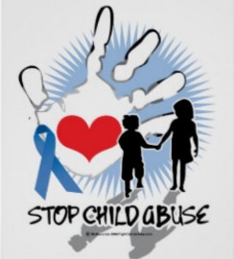  Learners create posters speaking against child abuse and also show where to go for help in case of abuse. | Use questions to review their understanding of the lesson  Ask learners to summarize what they have learnt

