Week Ending: | DAY: |  |  | Subject: Creative Arts
Duration: 60mins per lesson |  |  |  | Strand: Performing Arts
Class: B3 | Class Size: |  |  | Sub Strand: Thinking and Exploring Ideas
Content Standard:  Demonstrate understanding of how to generate own ideas for artistic expressions on the people. |  |  | Indicator:  B3 2.1.1.2 generate ideas from performing artworks performed in other African communities for creating own visual artworks |  |  | Lesson:  1 OF 1
Performance Indicator:  Learners can generate ideas from performing artworks performed in other African communities for creating own visual artworks |  |  |  |  | Core Competencies:  Decision Making Creativity, Innovation Communication
Teaching/ Learning Resources |  | Photos, videos, art paper, colors and traditional art tools
References: Creative Arts Curriculum Pg. 63
DAY | PHASE 1: STARTER | PHASE 2: MAIN | PHASE 3: PLENARY
 | show pictures of people performing the Indlamu dance to learners’  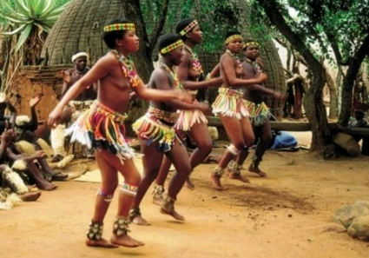  let learners observe and talk about the pictures | Learners are to study the music, dance and drama produced or performed in other countries in Africa  Indlamu of South Africa.  Indlamu is a traditional Zulu War dance from southern Africa. The dance is characterized by the dancer lifting one foot over his/her head and bringing it down sharply, etc.  Examine the resources, elements, instruments available for composing and performing the arts under study and how they are acquired | Ask learners to talk about what they enjoyed most during the lesson
 | Review the previous lesson with questions and answers | Invite a resource person to demonstrate the dance to learners.  Assessment: Learners dance in groups and in turns | Learners observe and appreciate the performance of others

