SCHEME OF LEARNING- WEEK 11
BASIC ONE
Week Ending: |  | DAY: |  |  |  |  | Subject: History
Duration: 60mins per lesson |  |  |  |  |  |  | Strand: My Country Ghana
Class: B1 |  | Class Size: |  |  |  |  | Sub Strand: Some selected individuals
Content Standard:  B1.2.5.1. Show understanding of significant roles played by Ghanaians from different walks of life |  |  |  |  | Indicator:  B1.2.5.1.1 Identify Ghanaians of diverse fields who have contributed significantly to national development |  |  |  | Lesson:  1 OF 1
Performance Indicator:  Learners can identify Ghanaians of diverse fields who have contributed significantly to national development |  |  |  |  |  | Core Competencies:  Learners to become critical thinkers and digital literates
Teaching/ Learning Resources |  |  | Wall charts, wall words, posters, video clip, etc.
New words
References: History Curriculum Pg. 5
DAYS | PHASE 1: STARTER |  |  | PHASE 2: MAIN |  |  |  | PHASE 3: PLENARY
 | Show pictures of Ephraim Amu to learners for them to talk about it.  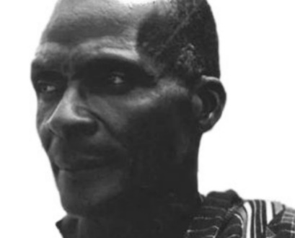 |  |  | Identify Ghanaians of diverse professions who have contributed significantly to national development.  e.g. Ephraim Amu  EPHRAIM AMU  Ephriam Amu born on 13 Sept. 1899 in Peki-Avetile, was a Ghanaian composer, musicologist and a teacher. His father was Stephen Amuyaa and mother Sarah Akoram Ama. Amu started school in May 1906 and entered the Peki-Biengo E.P boarding middle school, where he showed much interest in music and agriculture. Amu became a professional teacher after completing his 4-year teacher catechist training in 1919. Amu composed several musical pieces, among them are;  Fare the well, Mawo do na yesu, Dwonto, Isreal hene, Yaanom abibirima, etc.  Let learners listen to songs composed by Ephraim Amu. |  |  |  | Ask learners series of questions to review their understanding of the lesson  Ask learners to summarize what they have learnt  Learners to read and spell the key words on the board.
 | Ask learners questions to review their understanding in the previous lesson. |  |  | Guide learners to study more about Ephraim Amu and talk of his achievements using the internet.  Role play what learners want to be in future |  |  |  | Ask learners series of questions to review their understanding of the lesson  Ask learners to summarize what they have learnt

