SECOND TERM
WEEKLY LESSON NOTES
WEEK 10
Week Ending: |  | DAY: |  | Subject: Mathematics
Duration: 60MINS |  |  |  | Strand: Geometry & Measurement
Class: B9 |  | Class Size: |  | Sub Strand: Shapes and Space
Content Standard:  B9.3.1.1 Apply the properties of angles at a point, angles on a straight line, vertically opposite angles, corresponding, angles to` solve problems |  |  | Indicator:  B9.3.1.1.1 Derive the formula for calculating the sum of angles in any polygon and use this to calculate the value of missing angles in polygons |  |  | Lesson:  1 of 1
Performance Indicator:  Learners can apply the formula to find missing angles and solve problems involving polygons. |  |  |  | Core Competencies:  Communication and Collaboration (CC) Critical Thinking and Problem solving (CP)
References: Mathematics Curriculum Pg. 196
New words: Polygon, Triangle, Quadrilateral, Pentagon, Hexagon, Interior Angle
Phase/Duration | Learners Activities |  |  |  | Resources
PHASE 1: STARTER | Play a quick "name the polygon" game. Show various shapes (triangles, squares, rectangles, etc.) and have learners identify them by name.  Briefly introduce the concept of interior angles: the angles formed inside a polygon by its sides.  Share performance indicators and introduce the lesson.
PHASE 2: NEW LEARNING | Review the characteristics of different polygons: triangles (3 sides, 180° interior angle sum), quadrilaterals (4 sides, varied interior angle sums), pentagons (5 sides), hexagons (6 sides), etc.  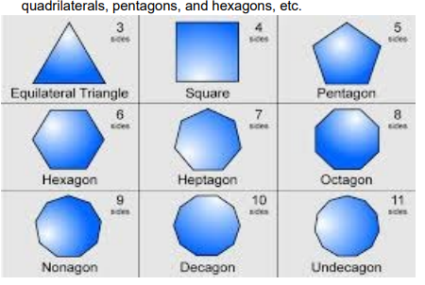  Create a visual chart on the board, classifying polygons by their number of sides and using different colors or shapes for each category.  Engage learners in identifying and naming new examples of polygons.  Introduce the concept of the angle sum formula for polygons: (n - 2) × 180°, where n is the number of sides.  Guide learners through the derivation of the formula using a simple triangle and gradually adding sides to form various quadrilaterals and pentagons.  Emphasize that the formula applies to any polygon, regardless of its shape or regularity.  Practice using the formula to calculate the sum of interior angles in different polygons. Provide examples with triangles, quadrilaterals, pentagons, and hexagons.  Challenge learners to find missing angles in polygons if given some angles and the number of sides.  Encourage them to explain their reasoning and calculations clearly.  Present a more challenging problem involving a complex polygon with missing angles.  Have learners work in pairs or small groups to solve it using the formula and their understanding of interior angles.  Assessment  1: Derive and use the formula (n - 2) × 180 ° and calculate the value of x (interior and angles of a triangle)  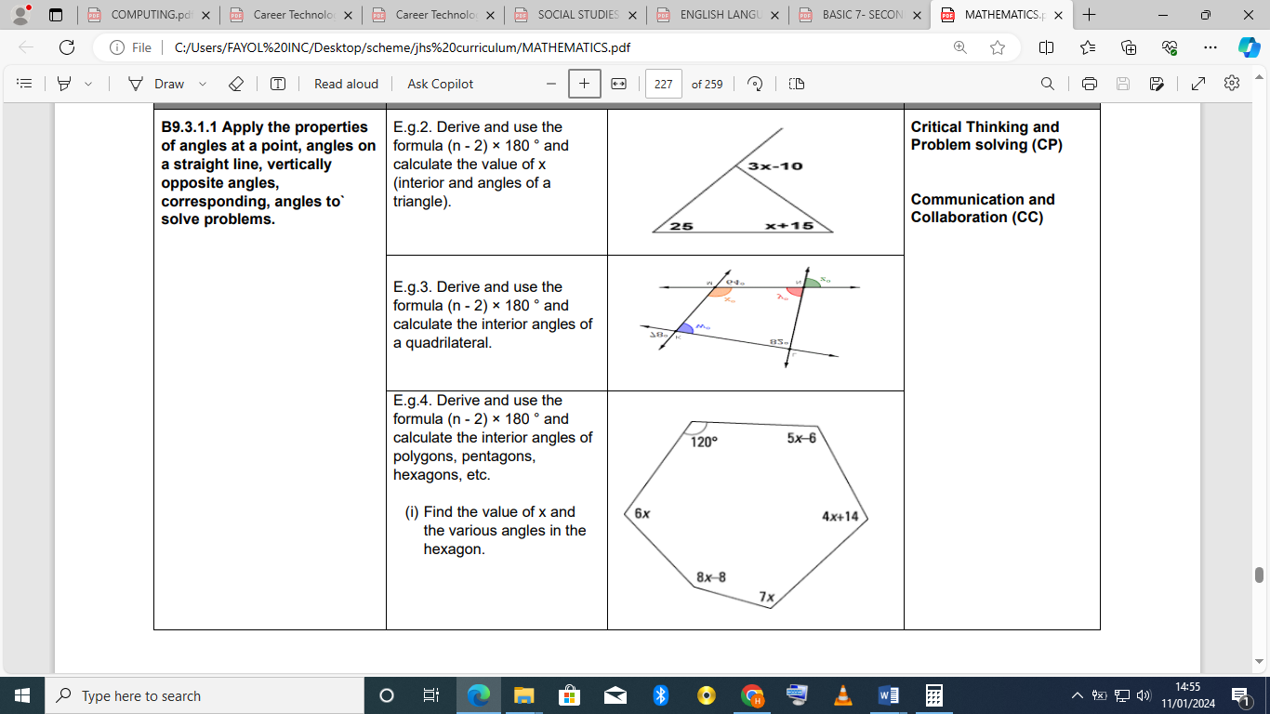  2: Derive and use the formula (n - 2) × 180 ° and calculate the interior angles of a quadrilateral  3: Derive and use the formula (n - 2) × 180 ° and calculate the interior angles of polygons, pentagons, hexagons,  (i) Find the value of x and the various angles in the hexagon |  |  |  | manipulatives like counters or algebra tiles
PHASE 3: REFLECTION | Use peer discussion and effective questioning to find out from learners what they have learnt during the lesson.  Take feedback from learners and summarize the lesson.

Week Ending: |  | DAY: |  | Subject: Mathematics
Duration: 60MINS |  |  |  | Strand: Geometry & Measurement
Class: B9 |  | Class Size: |  | Sub Strand: Shapes and Space
Content Standard:  B9.3.1.1 Apply the properties of angles at a point, angles on a straight line, vertically opposite angles, corresponding, angles to` solve problems |  |  | Indicator:  B9.3.1.1.2 Identify similar and congruent triangles and use the knowledge to solve related problems |  |  | Lesson:  1 of 1
Performance Indicator:  Learners can apply the AA, SSS, and SAS similarity criteria to solve for missing angles in similar triangles. |  |  |  | Core Competencies:  Communication and Collaboration (CC) Critical Thinking and Problem solving (CP)
References: Mathematics Curriculum Pg. 198
New words: Triangle, Similar, Congruent, Corresponding Angles, Proportional Sides, AA Similarity,
Phase/Duration | Learners Activities |  |  |  | Resources
PHASE 1: STARTER | Play a "Guess the Triangle" game. Describe different triangles by their properties (number of sides, side lengths, angle measures) and have learners guess if they are similar, congruent, or neither.  Share performance indicators and introduce the lesson.
PHASE 2: NEW LEARNING | Define and differentiate between similar and congruent triangles, emphasizing corresponding angles and proportional sides in similar triangles and identical side lengths and angles in congruent triangles.  Explain the AA, SSS, and SAS similarity criteria with clear visuals and examples.  Example 1: Recognise similar triangles and solve for the values of the indicated angles in the diagram below:  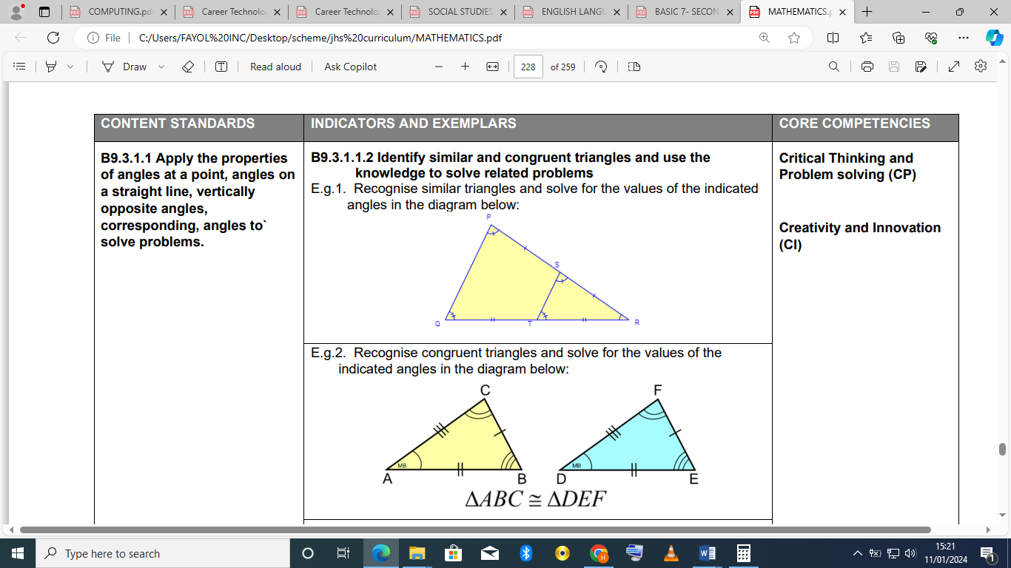  Example 2: Recognise congruent triangles and solve for the values of the indicated angles in the diagram below  Example 3: Determine the value of x (using knowledge in similarity and congruency).  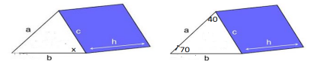  Briefly introduce the HL congruence rule, focusing on right triangles with hypotenuse and a leg having the same length.  Practice recognizing similar and congruent triangles based on the given diagrams you mentioned. Guide learners through identifying corresponding angles and proportional sides to justify their answers.  Ask learners to solve for missing angles in the similar triangles using the appropriate similarity criteria and proportional side ratios.  For the congruent triangle, apply the HL congruence rule to find the missing angle based on the given hypotenuse and leg lengths.  Present a real-world problem involving similar triangles, such as calculating the height of a tree based on its shadow and another object's height.  Challenge learners to solve the problem using the AA similarity criteria and their understanding of proportional sides.  Encourage them to think of other situations where similar or congruent triangles might be present in daily life. |  |  |  | manipulatives like counters or algebra tiles
PHASE 3: REFLECTION | Use peer discussion and effective questioning to find out from learners what they have learnt during the lesson.  Take feedback from learners and summarize the lesson.

