Week Ending: |  |  | DAY: |  | Subject: Mathematics
Duration: 50mins |  |  |  |  | Strand: Algebra
Class: B4 |  |  | Class Size: |  | Sub Strand: Patterns and Relationships
Content Standard:  B4.2.1.2. Translate among different representations of a pattern, such as a table, a chart or concrete material |  |  |  | Indicator:  B4.2.1.2.1 create a concrete representation of a given pattern displayed in a table or chart |  |  | Lesson:  1 OF 1
Performance Indicator:  Learners can create a concrete representation of a given pattern displayed in a table or chart |  |  |  |  |  | Core Competencies:  Problem Solving skills; Critical Thinking; Justification of Ideas
Teaching/ Learning Resources |  | Patterns made from Manila cards
New words
References: Mathematics Curriculum Pg. 30
DAYS | PHASE 1: STARTER | PHASE 2: MAIN | PHASE 3: PLENARY
Monday | Engage learners to sing the song  WE CAN COUNT  We class four  We can count  We count 1,2,3,4,5  We count 6,7,8,9,10  We class four can count very well. | Provide a table showing a pattern (involving one operation) such as the one below.  Students to complete the table and create a concrete representation using linking cubes or other manipulative.  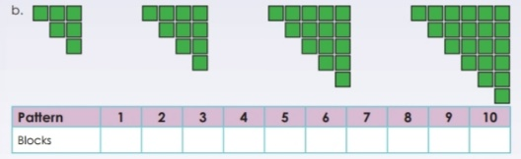 | Ask learners to tell you what they have learnt  Give learners individual or home task.  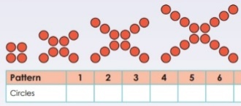
Tuesday | Engage learners to sing the song  WE CAN COUNT  We class four  We can count  We count 1,2,3,4,5  We count 6,7,8,9,10  We class four can count very well. | Provide a table showing a pattern (involving one operation) such as the one below.  Students to complete the table and create a concrete representation using linking cubes or other manipulative.  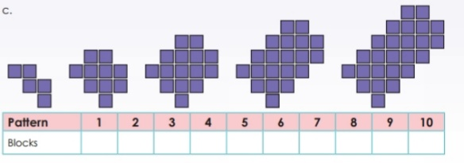 | Ask learners to tell you what they have learnt  Give learners individual or home task.
Wednesday | Review learners understanding in the previous lesson using questions and answers  Engage learners to play games and sing songs to begin the lesson. | Provide a table showing a pattern (involving one operation) such as the one below.  Students to complete the table and create a concrete representation using linking cubes or other manipulative.  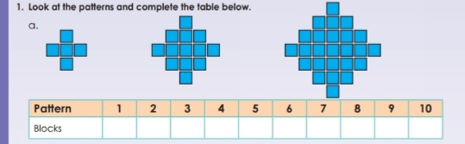 | Ask learners to tell you what they have learnt  Give learners individual or home task.
Thursday | Review learners understanding in the previous lesson using questions and answers  Engage learners to play games and sing songs to begin the lesson. | Provide a table showing a pattern (involving one operation) such as the one below.  Students to complete the table and create a concrete representation using linking cubes or other manipulative.  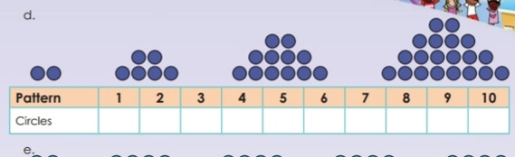 | Ask learners to tell you what they have learnt  Give learners individual or home task.
Friday | Let learners solve this  Using only addition, how can you use eight eights to get the number 1000?  Answer: 888+88+8+8+8 | Provide a table showing a pattern (involving one operation) such as the one below.  Students to complete the table and create a concrete representation using linking cubes or other manipulative.  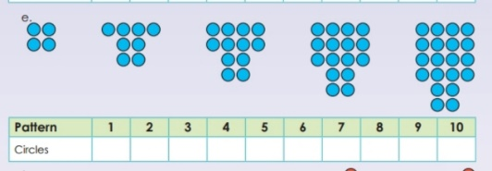 | Ask learners to tell you what they have learnt  Give learners individual or home task.

