Week Ending: | DAY: |  |  | Subject: Creative Arts
Duration: 60mins per lesson |  |  |  | Strand: Performing Arts
Class: B3 | Class Size: |  |  | Sub Strand: Appreciating and Appraising
Content Standard:  Demonstrate understanding of how to generate own ideas for artistic expressions on the people. |  |  | Indicator:  B3.2.4.6.2 /B3.2.4.7.2 Use the agreed guidelines to examine and derive meaning from own and others’ performances. |  |  | Lesson:  1 OF 1
Performance Indicator:  Learners can use the agreed guidelines to examine and derive meaning from own and others’ performances |  |  |  |  | Core Competencies:  Decision Making Creativity, Innovation Communication
Teaching/ Learning Resources |  | Photos, videos, art paper, colors and traditional art tools
References: Creative Arts Curriculum Pg. 67
DAY | PHASE 1: STARTER | PHASE 2: MAIN | PHASE 3: PLENARY
 | Use questions and answers to revise the previous lesson with learners.  Engage learners to play games and sing songs to begin the lesson | The easiest way to understand and appreciate a performance is to develop a relevance and appropriate criteria or checklist  Guide learners to create a checklist or criteria for appreciating and appraising a performance;  - Creative process  - Subject matter  - Selection and use of instruments and elements  - Styles and techniques  - Originality or creativity  - Use of space  - Selection and use of costumes  - Symbolism and cultural relevance  - Aesthetic qualities  - suitability | Use questions to review learners understanding of the lesson.  Ask learners to tell the class what they have learnt.  Call learners to summarize the main points of the lesson.
 | show pictures of people performing the Indlamu dance to learners’  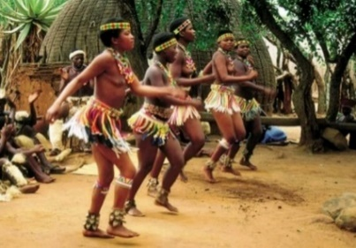  let learners observe and talk about the pictures | Lead a discussion to explain the criteria with learners.  Now let learners use the checklist to appreciate and appraise a previous art performance in class. e.g. the ‘Indlamu’ Dance.  Put learners into groups of 2 or 3 depending on the size of the class.  Invite each group to perform the ‘Indlamu’ dance as others will be observing.  Set up a three member judge to use the checklist or criteria to appraise the performance of each group. | Use questions to review learners understanding of the lesson.  Ask learners to tell the class what they have learnt.  Call learners to summarize the main points of the lesson.

