Week Ending: |  |  | DAY: |  | Subject: Mathematics
Duration: 50mins |  |  |  |  | Strand: Number
Class: B3 |  |  | Class Size: |  | Sub Strand: Number Operations
Content Standard:  B3.1.2.5 Demonstrate an understanding of multiplication up to 5 x 5 |  |  |  | Indicator:  B3.1.2.5.2 represent and explain multiplication using rectangular arrays. |  |  | Lesson:  1 OF 1
Performance Indicator:  Learners can represent and explain multiplication using equal groupings. |  |  |  |  |  | CORE COMPETENCE:  Problem Solving skills; Critical Thinking; Justification of Ideas;
Teaching/ Learning Resources |  | Number line cards, bottle caps, bowls, pebbles
New words
References: Mathematics Curriculum Pg. 54
DAY | PHASE 1: STARTER | PHASE 2: MAIN | PHASE 3: PLENARY
 | Ask learners to draw two smileys to express how they feel that moment.  Have learners to present their smileys to whole class for discussion. | Guide learners to use rectangular arrays to solve multiplication questions.  e.g. To find 2 × 3 = ?  Learners arrange 2 straws vertically (legs) and put across it with 3 horizontal ones (arms).  Learners count the number of intersections.  Learners model different multiplication sentences by drawing vertical lines to represent the legs and horizontal lines across them to represent the arms and then count the number of intersections as the product. | Give learners task to complete whiles you go round to guide those who don’t understand.  Give remedial learning to those who special help.
 | Engage learners in the “Jump Counting” game  Have learners count while jumping with each count. Challenge them to count by twos, fives, or tens! | Develop and build the multiplication chart (up to 9 x 9) and have learners practice reading the chart  Call learners randomly to answer some multiplication facts. The answer should be given within a given duration to make it more fun. | Give learners task to complete whiles you go round to guide those who don’t understand.  Give remedial learning to those who special help.
 | Let learners draw a picture of a favorite place in the world.  Then write five or more words that remind them of that place.  Have learners to paste their drawings on the classroom wall to create a gallery. | Guide Learners to model multiplication facts on the number line.  e.g. to find 3 x 4 =?  This can also be read as 3 groups of 4.  e.g. to find 2 x 3= ?  This can also be read as 2 groups of 3.  0 1 2 3 4 5 6 7 8 9 10  2 X 3 = 6 | Give learners task to complete whiles you go round to guide those who don’t understand.  Give remedial learning to those who special help.
 | Engage learners to cut out some 2D shapes at your start signal.  Have learners to paste the cut outs on the classroom wall | Draw a 6 by 6-multiplication chart and use it as a game board to play the 3-in-a-line game with a pair of dice or playing cards. Players take turns in throwing a pair of dice and mark (or cover) the product made in a throw with his/her marker (or counter). | Give learners task to complete whiles you go round to guide those who don’t understand.  Give remedial learning to those who special help.
 | Play games and sing songs to begin the lesson.  Have learners to solve some examples to review their understanding of the previous lesson | Learners find doubles of given numbers and skip count in 3, 4, and 5.  Engage learners in activities to find the doubles of numbers.  e.g. double of 4 is 8  Double of is 10 Double of is 12  Draw a 30-number grid and let learners jump and skip count of 3, 4 and 5  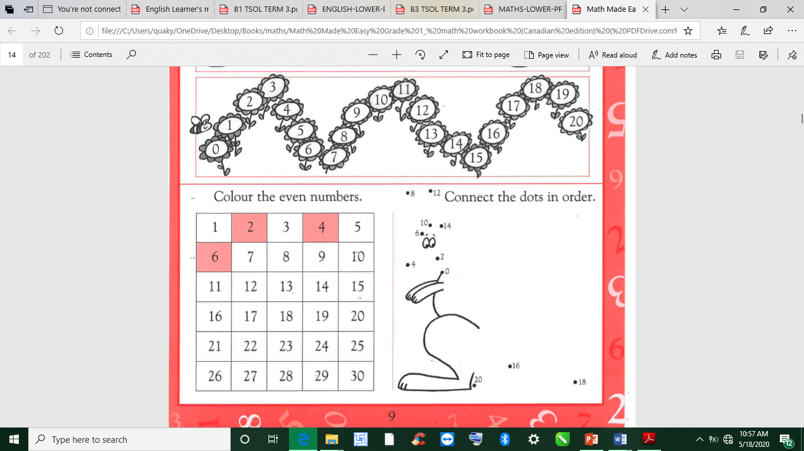 | Give learners task to complete whiles you go round to guide those who don’t understand.  Give remedial learning to those who special help.

