SCHEME OF LEARNING- WEEK 5
BASIC ONE
Week Ending: |  | DAY: |  |  |  |  | Subject: History
Duration: 60mins per lesson |  |  |  |  |  |  | Strand: My Country Ghana
Class: B1 |  | Class Size: |  |  |  |  | Sub Strand: How Ghana Got Its Name
Content Standard:  B1.2.3.1. Demonstrate understanding of why Ghana used to be called the ‘Gold Coast’ |  |  |  |  | Indicator:  B1.2.3.1.2 recall when the name Ghana came into formal use |  |  |  | Lesson:  1 OF 1
Performance Indicator:  Learners can recall when the name Ghana came into formal use |  |  |  |  |  | Core Competencies:  Learners to become critical thinkers and digital literates
Teaching/ Learning Resources |  |  | Wall charts, wall words, posters, video clip, etc.
New words
References: History Curriculum Pg. 4
DAYS | PHASE 1: STARTER |  |  | PHASE 2: MAIN |  |  |  | PHASE 3: PLENARY
 | Show pictures of Amon Kotei to learners for them to talk about it  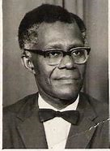 |  |  | Discuss the role played by other individuals in the change of name from Gold Coast to Ghana  After the change of name and independence, a new coat of arms was also designed. It was designed by Amon Kotei.  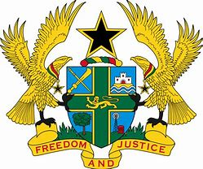 |  |  |  | Ask learners series of questions to review their understanding of the lesson  Ask learners to summarize what they have learnt  Learners to read and spell the key words on the board
 | Learners to identify the names of important personalities on a chart |  |  | Learners to dramatize a scene in parliament in changing the name Gold Coast to Ghana.  At the parliament house, there are opposing views. Group learners into two opposing views.  Learners must debate on the change of name and why. |  |  |  | Ask learners to tell the class what they have learnt.  Call learners in turns summarize the lesson

