Week Ending: | DAY: |  |  |  |  | Subject: Science
Duration: 60mins per lesson |  |  |  |  |  | Strand: Systems
Class: B2 | Class Size: |  |  |  |  | Sub Strand: The Human Body System
Content Standard:  B2.3.1.1 Recognise that different parts of the human body work interdependently to perform a specific function |  |  |  | Indicator:  B2.3.1.1.1 know the functions of the human body parts such as eyes, ears, mouth, nose, arms, legs and hands |  |  | Lesson:  1 OF 1
Performance Indicator:  Learners can know the functions of the human body parts such as eyes, ears, mouth, nose, arms, legs and hands |  |  |  |  | Core Competencies:  Problem Solving skills; Critical Thinking; Justification of Ideas;
Teaching/ Learning Resources |  |  | Pictures, videos, paper, pencils, crayons
New words
References: Science Curriculum Pg. 40
DAY | PHASE 1: STARTER | PHASE 2: MAIN | PHASE 3: PLENARY
 | Use questions and answers to review what they learnt in the previous lesson  Example: the mouth is used for………..  The hands are used for……….  Legs are used for…………… | Learners talk about the biological uses of the human body parts in pairs.  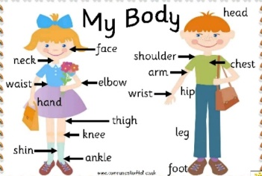  Have learners to discuss the uses of the parts of the body. | Use questions and answers to review learners understanding in the lesson.
 | Use questions and answers to review the previous lesson with learners | Let learners role play with the uses of the parts of the body.  Example: “I am called eyes”-the body sees with me. | Ask learners to talk about what they enjoyed most during the lesson
 | Get a viral picture, a trending news on twitter, Facebook, YouTube and other social media handles.  Discuss what is trending and invite learners to share their opinions on them. | In groups learners brainstorm and talk about what will happen if some parts of the body are absent or not working well?  Let learners act some of scenarios highlighted  Example: learners walk with one leg etc. | Ask learners to talk about what they enjoyed most during the lesson  Use questions and answers to review learners understanding in the lesson

