Week Ending: | DAY: |  |  |  | Subject: Science
Duration: 60mins per lesson |  |  |  |  | Strand: Systems
Class: B3 | Class Size: |  |  |  | Sub Strand: The Human Body System
Content Standard:  B3.2.1.1 Recognize that some events in our environment occur recurrently |  |  | Indicator:  B3.3.1.1.1 explain that the external parts of the human body work interdependently to perform a function |  |  | Lesson:  1 OF 1
Performance Indicator:  Learners can explain that the external parts of the human body work interdependently to perform a function |  |  |  | Core Competencies:  Problem Solving skills; Critical Thinking; Justification of Ideas;
Teaching/ Learning Resources |  | Learners, pictures, videos, paper, pencils, crayons
References: Science Curriculum Pg. 55
DAY | PHASE 1: STARTER | PHASE 2: MAIN | PHASE 3: PLENARY
 | Engage pupils in songs on the various parts of the body, e.g. head, shoulders, knees and toes, show me your head, my head, my shoulders my knees, my toes. | Let learner’s role play the functions of parts of the human body.  E.g. I am eyes, the body sees with me. I see and tell the body dangers ahead.  I am nose, the body breathe through me. I smell things etc. | Ask learners to tell you what they have learnt and what they will like to learn in the next lesson  Let learners read the keywords written on the board
 | Use questions and answers to review what they learnt in the previous lesson  Example: the mouth is used for………..  The hands are used for……….  Legs are used for…………… | Learners brainstorm on how the various parts of the human body support each other to perform various functions,  E.g. assuming a dog is barking towards you, how do the eyes, ears, feet help you to recognize danger and escape?  Assessment: Give learners a lot of scenarios and get interesting answers from them. | Ask learners to tell you what they have learnt and what they will like to learn in the next lesson  Let learners give scenarios and tell how they will react to the situations
 | Learners recite rhymes  Humpty Dumpty  Humpty Dumpty sat on the wall,  Humpty Dumpty had a great fall,  All the kings horses and  all the kings men,  Couldn’t put dumpty together again | Let learners relate to some of the scenarios and draw them in their work books  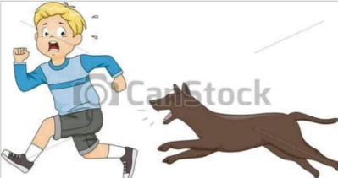 | Ask learners to talk about what they enjoyed most during the lesson  Let Learners display their drawings for appreciation

