WEEK 9
Week Ending: |  | DAY: |  | Subject: Social Studies
Duration: 50mins |  |  |  | Strand: Environment
Class: B7 |  | Class Size: |  | Sub Strand: Understanding Our Natural World
Content Standard:  B7.1.3.1. Show understanding of the world around us |  |  | Indicator:  B7.1.3.1.1. Examine major physical features of the earth |  | Lesson:  1 OF 2
Performance Indicator:  Learners can mention some major physical features of the earth. |  |  |  | Core Competencies:  Creativity and Innovation, Comm & Collaboration, Digital Literacy,  Critical thinking and Problem solving.
References: Social Studies Curriculum Pg. 9-10
Phase/Duration | Learners Activities |  |  |  |  | Resources
PHASE 1: STARTER | Revise with learners to review their understanding in the previous lesson.  Share performance indicators with learners.
PHASE 2: NEW LEARNING | Guide learners to identify some major features of the earth such as mountain ranges, rivers, oceans, hot deserts and tropical rainforest.  With the use of maps, guide learners to find the locations of the following major physical features:  i. Mountain ranges, including Akuapim-Togo, Gambaga, Kwahu, Himalayas, Rockies, Andes and Alps  ii. Rivers, including the River Bia, Tano, Ankobra, Pra, Densu, Volta, Nile, Niger, Congo, Ganges, Yangtze, Amazon, Mississippi  iii. Oceans: Atlantic, Arctic, Southern, Indian, Pacific  iv. Hot deserts, including Sahara, Kalahari, Gobi, Arabian  v. Tropical rainforests, including the Amazon Rainforest  Assessment  - Mention any four rivers in Ghana. |  |  |  |  | Maps and Atlas
PHASE 3: REFLECTION | Use peer discussion and effective questioning to find out from learners what they have learnt during the lesson.  Take feedback from learners and summarize the lesson.

Week Ending: |  | DAY: |  | Subject: Social Studies
Duration: |  |  |  | Strand: Environment
Class: B7 |  | Class Size: |  | Sub Strand: Understanding Our Natural World
Content Standard:  B7.1.3.1. Show understanding of the world around us |  |  | Indicator:  B7.1.3.1.1. Examine major physical features of the earth. |  | Lesson:  2 OF 3
Performance Indicator:  Learners can explore the major physical features of the earth. |  |  |  | Core Competencies:  Creativity and Innovation, Comm & Collaboration, Digital Literacy,  Critical thinking and Problem solving.
References: Social Studies Curriculum Pg. 9 -10
Phase/Duration | Learners Activities |  |  |  |  | Resources
PHASE 1: STARTER | Revise with learners to review their understanding in the previous lesson.  Share performance indicators with learners.
PHASE 2: NEW LEARNING | Revise with learners to mention some of the mountain ranges in Ghana.  Example:  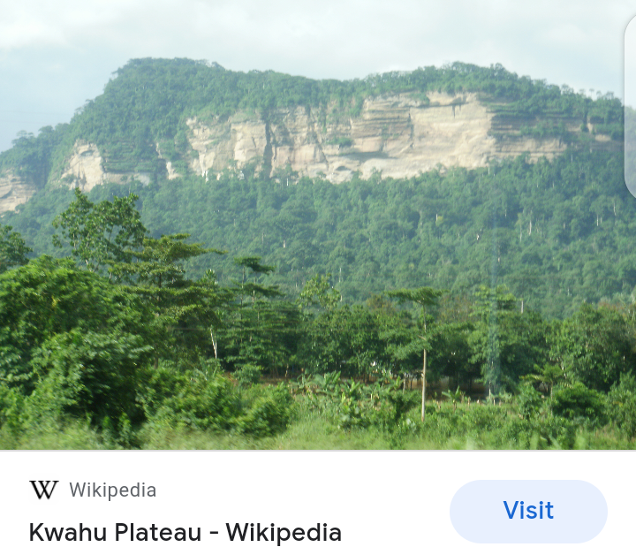  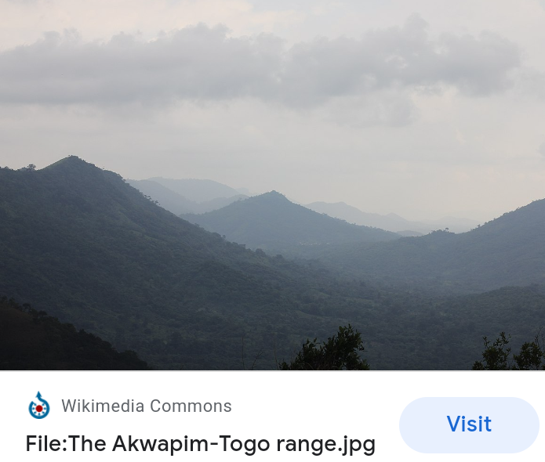  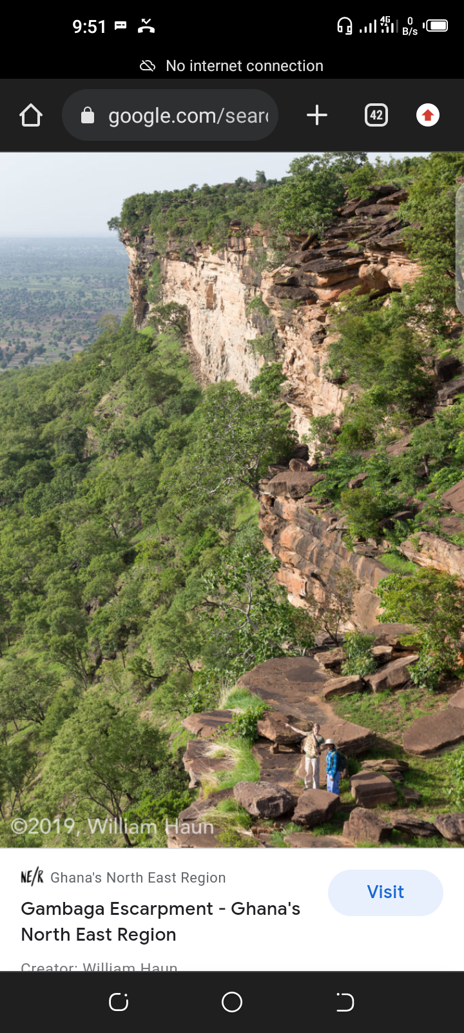  Engage learners to discuss human activities that affect the Major mountain ranges.  Example: mining, grazing by livestock, tourism, energy production, etc.  Learners discuss ways of maintaining the beauty of the mountain ranges.  Use pictures / photographs to assist pupils Identify some major rivers in Ghana.  Example:  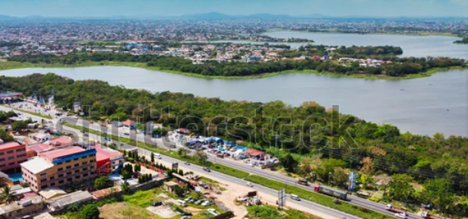  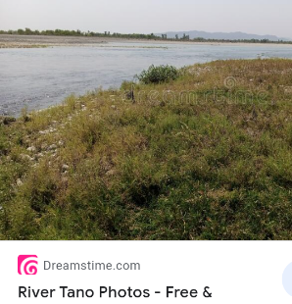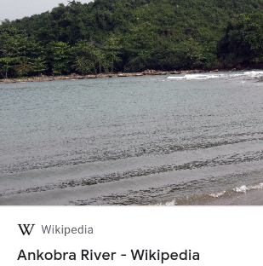  Engage learners to discuss human activities that affect the Rivers.  Example:  - The discharge of industrial chemicals  - Poor fishing methods such as the use of dangerous chemicals like DDT.  - Dumping of solid and liquid waste, etc.  Discuss the effects of plastic pollution on water bodies including streams, ponds, rivers, dams and lakes. |  |  |  |  | Pictures and Charts
PHASE 3: REFLECTION | Use peer discussion and effective questioning to find out from learners what they have learnt during the lesson.  Take feedback from learners and summarize the lesson.

