WEEK 5
Week Ending: |  | DAY: |  | Subject: Science
Duration: 100mins |  |  |  | Strand: Cycles
Class: B9 |  | Class Size: |  | Sub Strand: Earth science
Content Standard:  B9.2.1.1 Demonstrate an understanding of the Nitrogen cycle as a repeated pattern of change in nature, and how it relates to the environment |  |  | Indicator:  B9.2.1.1.1 Explain the process of the nitrogen cycle as a repeated pattern in nature |  |  |  | Lesson:  1 of 2
Performance Indicator:  Learners can identify and understand the different stages of the nitrogen cycle.  Learners can recognize the importance of the nitrogen cycle in the environment.  Learners can explain why the nitrogen cycle is a recurring process in nature. |  |  |  |  | Core Competencies:  Critical Thinking and Problem Solving, Communication and Collaboration, Digital Literacy
References: Science Curriculum Pg. 91
New words: Nitrogen Cycle, Nitrogen Fixation, Nitrification, Assimilation
Phase/Duration | Learners Activities |  |  |  |  | Resources
PHASE 1: STARTER | Display a picture of a healthy plant and a withered plant. Ask learners: "What do plants need to grow and stay healthy? What might be lacking in the withered plant?"  Share learning indicators and introduce the lesson.
PHASE 2: NEW LEARNING | Using pictures, guide learners to Identify the nitrogen cycle.  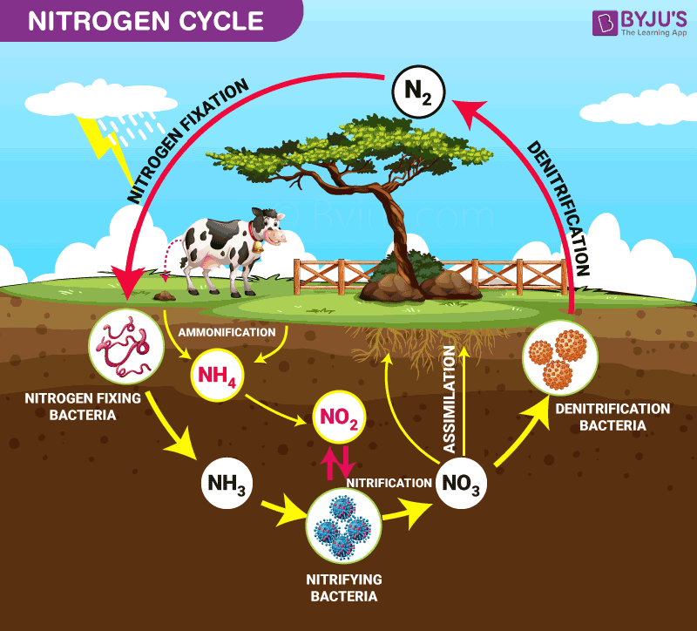  Learners should identify and make notes on the key components and processes of the cycle.  Explain the nitrogen cycle depicting processes such as:  1. Nitrogen Fixation: - Conversion of atmospheric nitrogen (N2) to ammonia (NH3) by specific bacteria or through abiotic processes like lightning.  2. Nitrification:- Two-step process where ammonia (NH3) is converted first to nitrite (NO2-) and then to nitrate (NO3-) by certain bacteria in the soil.  3. Assimilation:- Uptake and incorporation of nitrogen (often in the form of nitrate or ammonia) by plants to synthesize amino acids, proteins, and other organic molecules.  4. Ammonification (or Mineralization):- Decomposition of organic nitrogenous matter (like dead plants and animals) by decomposers, resulting in the release of ammonia (NH3) back into the soil.  5. Denitrification:- Conversion of nitrates (NO3-) and nitrites (NO2-) in the soil back to gaseous nitrogen (N2) or nitrous oxide (N2O) by certain bacteria, releasing it into the atmosphere.  Use visual aids like charts or diagrams to help learners understand each step. Discuss the role of bacteria and other organisms in these processes.  Let learners explain the relationship between the nitrogen cycle and the environment.  Example: Soil Fertility: The nitrogen cycle plays a key role in maintaining soil fertility by ensuring a continuous supply of essential nitrogen compounds that plants need for growth.  Air Quality: Denitrification releases nitrogen gases back to the atmosphere, maintaining a balance. However, excessive nitrogen can lead to the production of nitrous oxide, a greenhouse gas.  Water Quality: Excessive nitrates due to agricultural runoff can contaminate water, leading to problems like eutrophication, which can cause algal blooms and deplete oxygen in water bodies.  Discuss how plants rely on the nitrogen present in the soil, and how animals rely on plants (and other animals) for their nitrogen needs.  Emphasize the interconnectedness of all life forms and the environment within this cycle.  Assessment  1. What is the purpose of nitrogen fixation in the nitrogen cycle?  2. During which process is ammonia converted into nitrates?  3. Why is the nitrogen cycle important for the environment?  4. How does the repeated pattern of the nitrogen cycle ensure balance in nature? |  |  |  |  | Pictures and charts
PHASE 3: REFLECTION | Use peer discussion and effective questioning to find out from learners what they have learnt during the lesson.  Take feedback from learners and summarize the lesson.

Week Ending: |  | DAY: |  | Subject: Science
Duration: 100mins |  |  |  | Strand: Cycles
Class: B9 |  | Class Size: |  | Sub Strand: Earth science
Content Standard:  B9.2.1.1 Demonstrate an understanding of the Nitrogen cycle as a repeated pattern of change in nature, and how it relates to the environment |  |  | Indicator:  B9.2.1.1.2 Describe the importance of the nitrogen cycle to the environment |  |  |  | Lesson:  2 of 2
Performance Indicator:  Learners can understand the significance of nitrogen to the environment and recognize the role of certain plants, such as leguminous crops, in replenishing soil nitrogen. |  |  |  |  | Core Competencies:  Critical Thinking and Problem Solving, Communication and Collaboration, Digital Literacy
References: Science Curriculum Pg. 91
New words: Nitrogen Cycle, Leguminous Crops, Leaching, Bush Burning
Phase/Duration | Learners Activities |  |  |  |  | Resources
PHASE 1: STARTER | Display pictures of thriving crops and barren fields. Ask learners: "Why do you think one field is lush and the other is barren? How might nitrogen play a role?"  Share learning indicators and introduce the lesson.
PHASE 2: NEW LEARNING | 1. Describe the importance of nitrogen to the environment.  2. Carry out a project to show how certain plants such as leguminous crops can replenish nitrogen in the soil.  3. Predict what will happen if the nitrogen cycle is interrupted by actions such as leaching, bush burning, and destruction of leguminous plants  Engage learners to describe the importance of nitrogen to the environment.  Discuss how nitrogen is a critical component of amino acids, proteins, and DNA, which are essential for life.  Highlight the fact that the atmosphere is about 78% nitrogen, but plants and animals can't directly use it in its gaseous form.  Explain the need for the nitrogen cycle to convert atmospheric nitrogen into a usable form for plants and animals.  Carry out a project to show how certain plants such as leguminous crops can replenish nitrogen in the soil.  In groups, learners can plant leguminous crops in small pots. In another set of pots, plant non-leguminous crops.  Observe growth over a period, noting differences.  Research or discuss the role of nitrogen-fixing bacteria present in the roots of leguminous plants.  Conclude by discussing how leguminous crops are beneficial to agriculture and the environment.  Predict what will happen if the nitrogen cycle is interrupted by actions such as leaching, bush burning, and destruction of leguminous plants.  Introduce each disruption (leaching, bush burning, and destruction of leguminous plants) one by one and ask learners to predict the effects.  Guide the discussion toward understanding the fragility of the nitrogen cycle and the consequences of its interruption on soil fertility, crop production, and the broader ecosystem.  Assessment  1. Why is nitrogen important for plants and animals?  2. How do leguminous crops aid in replenishing soil nitrogen?  3. What is the consequence of bush burning on the nitrogen cycle?  4. Predict an effect on the environment if leguminous plants are massively destroyed. |  |  |  |  | Pictures and charts
PHASE 3: REFLECTION | Use peer discussion and effective questioning to find out from learners what they have learnt during the lesson.  Take feedback from learners and summarize the lesson.

