Week Ending: | DAY: |  |  | Subject: Computing
Duration: 60mins |  |  |  | Strand: Introduction To Computing
Class: B5 | Class Size: |  |  | Sub Strand: Introduction To MS-Windows Interface
Content Standard:  B5.1.2.1. Demonstrate the use of the Desktop Background as well as working with folders |  |  | Indicator:  B5.1.2.1.3.-4 Describe how to Personalize the Desktop |  |  | Lesson:  1 OF 1
Performance Indicator:  Learners can recognize and Personalize the Desktop Background and edit its images |  |  |  |  | Core Competencies:  Creativity and innovation. 2. Communication and collaboration.
Teaching/ Learning Resources |  | Computer, Laptop, Smartphone
References: Computing Curriculum Pg. 13
DAYS | PHASE 1: STARTER | PHASE 2: MAIN | PHASE 3: REFLECTION
 | Have leaners to write on a sheet of paper any three features of the computer desktop.  Engage leaners in the  “THE BALL GAME”  Ask learners to form a big circle, with one of the student holding the ball. The learner with the ball starts to mention a word.  He then throws the ball to another student to mention his.  Anyone who fails to mention his is out of the circle.  The last person becomes the winner. | Guide learners to customize the Start Menu and the Notification Area.  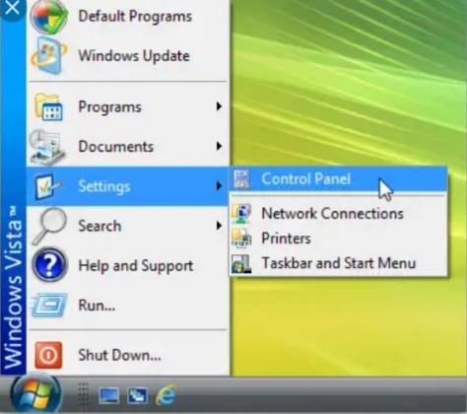  Guide learners to create shortcuts of icons on the computers’ desktop.  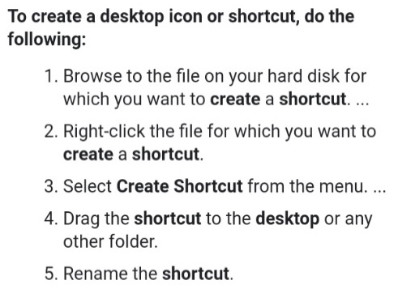 | Ask learners questions to review their understanding of the lesson.  Give learners task to do whiles you go round to guide those who need help.

