Week Ending: |  | DAY: |  |  |  | Subject: History
Duration: |  |  |  |  |  | Strand: Independent Ghana
Class: B6 |  | Class Size: |  |  |  | Sub Strand: The Republics
Content Standard:  Demonstrate an understanding of the Fourth Republic (1992 to date). |  |  |  |  | Indicator:  B6.6.1.1.1 Describe the events leading to the emergence of the Fourth Republic |  | Lesson:  1 OF 1
Performance Indicator:  - Learners can describe the events leading to the emergence of the Fourth Republic |  |  |  | Core Competencies:  The use of evidence to appreciate the significance of historical locations help learners to become critical thinkers and digital literates
Teaching/ Learning Resources |  |  | Wall charts, word cards, posters, video clip, etc.
New words | protest, opposition, movement, nationalism, nationalist, elite, Bill, delegation, prevail, devolution, constitutional, infrastructure, sanitation, empower, by-laws, elect, nominated
References: History Curriculum Pg. 44
DAYS | PHASE 1: STARTER | PHASE 2: MAIN | PHASE 3: REFLECTION
 | Prepare flash cards of the key words with the words on one side of the card and the meaning on the reverse of the flash card and give to them.  Get all the learners with the same key word to come to the front of the class to try to explain in their own words what they think it means and let the rest of the class choose the explanation that best fits the correct meaning.  - Did you enjoy the game?  - What words did you learn in the game? | Using pictures and charts, learners list the names of all the Presidents of the Fourth Republics and their dates of tenure.  Learners use the internet to find out some biographical details about presidents of the Fourth Republic of Ghana.  Example: John Dramani Mahama and Nana Addo Dankwa Akuffo Addo.  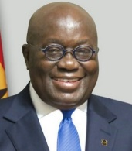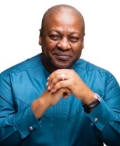  Have learners discuss some of thier policies and achievements for the country.  Assessment  Learners to write a short paragraph on why Ghana has become known as the Fourth Republic. | Let learners write on a piece of paper the following;  3 things they remember in the lesson  2 questions they would their partner to answer.  1 interesting fact of the lessson.  Homework  Prepare a speech about one of the presidents of the Fourth Republic using the information that they gathered.
 | Read out excerpts from speeches made by important individuals in the country. Let learners relate to the speeches and share ideas on such speeches.  Using questions and answers, review learners understanding of the previous lesson. | Show and discuss a documentary on the inauguration of a new President of Ghana.  Learners recount an inauguration they have witnessed or seen on Television.  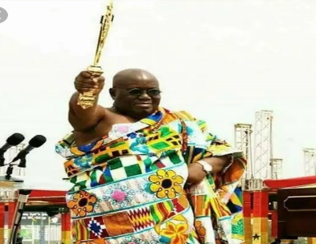  Prepare speeches and engage learners to role play inauguration of a new President.  Assessment  Learners make an information poster showing the events that led up to the formation of the Fourth Republic in Ghana. | Engage learners to summarize the lesson activities and tell what they will like to learn in the next lesson.  Homework  Prepare a speech about one of the presidents of the Fourth Republic using the information that they gathered.

