Week Ending: |  | DAY: |  |  |  | Subject: Science
Duration: 60mins per lesson |  |  |  |  |  | Strand: Humans And The Environment
Class: B3 |  | Class Size: |  |  |  | Sub Strand: Personal Hygiene And Sanitation
Content Standard:  B3.5.1.1 Recognize the importance of personal hygiene |  |  |  | Indicator:  B3.5.1.1.1 describe ways of keeping the environment clean |  |  | Lesson:  1 OF 1
Performance Indicator:  - Learners can describe ways of keeping the environment clean |  |  |  |  | Core Competencies:  Problem Solving skills; Critical Thinking; Justification of Ideas;
Teaching/ Learning Resources |  |  | Pictures, videos, cutlass, hoe, detergent, mop, scrubbing brush
Keywords | Clean, environment, scrub, sweep, dust, hoe, wipe, mop, detergent
References: Science Curriculum Pg. 59
DAYS | PHASE 1: STARTER | PHASE 2: MAIN | PHASE 3: REFLECTION
 | In a think pair-share activity, ask learners the following questions.  - Which places in your school can you scrub?  - Which places in your home can you scrub?  Collect responses from learners and write key ideas on the board. | - How do we keep our environment clean?  - How do you dispose off your rubbish at home and school?  Paste pictures of people sweeping on the board. Have learners observe all the pictures and talk about it in a think-pair-share activity.  Find out their observations and write key ideas on the board.  Explain to learners why it is important to sweep the school compound every day as well as the classrooms.  Assessment  Name three equipment used for cleaning. | Ask learners to write or say 10 words to express their thoughts of the lesson.  Homework  Mention three ways we can keep our school compound clean
 | Review learners understanding in the previous lesson using questions and answers  Engage learners to play games and sing songs to begin the lesson. | Present samples of common cleaning items to learners and have them identify them and talk about the use of those materials.  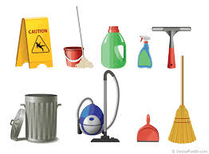  Re-inforce the learning by personally demonstrating the use of the cleaning items to learners.  Now allow learners to also demonstrate ways of keeping the environment clean with the available equipments.  Assessment  Draw four cleaning equipments | Ask learners questions to review their understanding of the lesson.  Have learners write 3 facts of the lesson on a sheet of paper and it in their pockets and learn it on their way home.  Homework  Write three reasons for keeping our environment clean.
 | Review learners understanding in the previous lesson using questions and answers  Engage learners to play games and sing songs to begin the lesson. | Present samples of common cleaning items to learners and have them identify them and talk about the use of those materials.  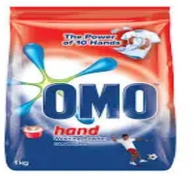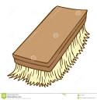  Re-inforce the learning by personally demonstrating the use of the cleaning items to learners.  Now allow learners to also demonstrate ways of keeping the environment clean with the available equipments.  Assessment  Draw four cleaning equipments | Ask learners questions to review their understanding of the lesson.  Have learners write 3 facts of the lesson on a sheet of paper and it in their pockets and learn it on their way home.  Next lesson  know how common skin diseases can be prevented

