Week Ending: | DAY: |  |  | Subject: Creative Arts
Duration: 60mins per lesson |  |  |  | Strand: Performing Arts
Class: B2 | Class Size: |  |  | Sub Strand: Thinking and Exploring Ideas
Content Standard:  Demonstrate understanding of how to generate own ideas for artistic expressions on the people. |  |  | Indicator:  B2 2.1.1.2 explore own experiences to talk about performing artworks that reflect people in other communities in Ghana |  |  | Lesson:  1 OF 1
Performance Indicator:  Learners can explore own experiences to talk about performing artworks that reflect people in other communities in Ghana |  |  |  |  | Core Competencies:  Decision Making and Creativity
Teaching/ Learning Resources |  | Photos, videos, art paper, colors and traditional art tools
References: Creative Arts Curriculum Pg. 30
DAY | PHASE 1: STARTER | PHASE 2: MAIN | PHASE 3: PLENARY
 | show pictures of people performing the Kpatsa dance to learners’  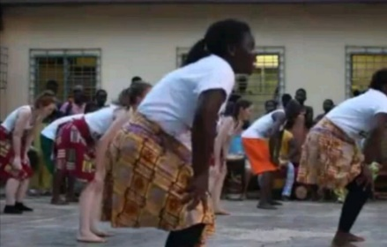  let learners observe and talk about the pictures | Guide Learners to brainstorm on performing artworks that are produced or performed by people in other parts of Ghana.  Today we shall look at the “Kpatsa” dance.  The “Kpatsa” dance is a traditional dance of the people of the Adangme people; it is said to be associated with abodo (dwarfs).Etc.  Guide learners to identify the props, costumes, instruments and elements, , used in performing the “Kpatsa” dance;  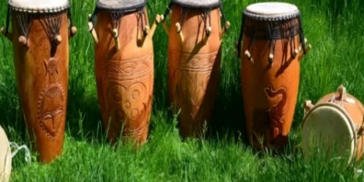 | Ask learners to talk about what they enjoyed most during the lesson
 | Review the previous lesson with questions and answers | Invite a resource person to demonstrate the dance to learners.  Assessment: Learners dance in groups and in turns | Learners observe and appreciate the performance of others

