Week Ending: |  |  | DAY: |  | Subject: Mathematics
Duration: 50mins |  |  |  |  | Strand: Geometry and Measurement
Class: B3 |  |  | Class Size: |  | Sub Strand: 2D & 3D Shapes
Content Standard:  B3.3.1.1 Analyse the relationships among and between 2-D shapes and 3-D objects according to a variety of attributes, including measurement |  |  |  | Indicator:  B3.3.1.1.2 draw and identify angles |  |  | Lesson:  1 OF 1
Performance Indicator:  Learners can describe 3D objects according to the shape of the faces, the number of edges and vertices |  |  |  |  |  | CORE COMPETENCE:  Problem Solving skills; Critical Thinking; Justification of Ideas;
Teaching/ Learning Resources |  | 2D and 3D shapes and objects boldly drawn on manila cards.
New words
References: Mathematics Curriculum Pg. 64
DAY | PHASE 1: STARTER | PHASE 2: MAIN | PHASE 3: PLENARY
 | Have learners recite familiar rhymes.  SHAPES  I am a square, I am square  You can see me everywhere  I have 4 sides,  I am a square, I am square  I am circle, I am circle  I go round and round and round  I have only one side  I am a circle round and round  I am a triangle, triangle  Am a pointing little shape  I have 3 sides  I am a triangle, triangle. | Revise with learners to explain faces, edges and vertices of 3d shapes.  Let's start with the "Face". A face is basically any surface that is flat. Take for example the top of a table or the front of a door. That's a flat surface.  Now let's explain the "Edge". The edge is basically the line that connects 2 faces together with each other. You would have a face on each end and a line connecting between  And finally the "Vertex". The vertex is the point or corner on a shape. This is where faces and edges come together and meet. That end becomes what you would call the vertex.  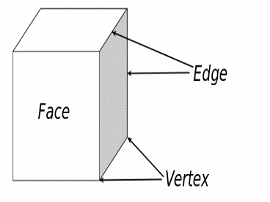  Have a look at this diagram below which shows the Faces, Edges & Vertices on the cube 3D shape | Ask learners to tell you what they have learnt  Give learners individual or home task
 | Engage learners to play games and sing familiar rhymes to begin the lesson. | Sort 2D shapes into larger categories (e.g. rhombuses, rectangles and squares are all four-sided shapes.) according to a common, shared attribute and justify sorting; | Ask learners to tell you what they have learnt  Give learners individual or home task
 | Engage learners to play games and sing familiar rhymes to begin the lesson. | Sort 2D shapes into larger categories (e.g. rhombuses, rectangles and squares are all four-sided shapes.) according to a common, shared attribute and justify sorting; | Ask learners to tell you what they have learnt  Give learners individual or home task
 | Engage learners to play games and sing familiar rhymes to begin the lesson. | Draw examples of shapes that belong to and those that do not belong to given category | Ask learners to tell you what they have learnt  Give learners individual or home task
 | Engage learners to play games and sing familiar rhymes to begin the lesson. | Measure the sides of a given polygon; Draw a polygon with given sides.  e.g. draw a rectangle with lengths 6cm and 3cm.  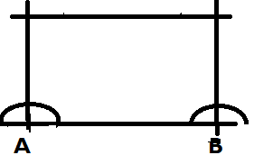  3cm  6cm  Assessment: Have learners draw several polygons with given sides. | Ask learners to tell you what they have learnt  Give learners individual or home task

