WEEKLY LESSON NOTES
WEEK 4
Week Ending: |  | Period: |  | Subject: Career Technology
Duration: |  |  |  | Strand: Tools, Equipment & Processes
Class: B7 |  | Class Size: |  | Sub Strand: Cutting/Shaping
Content Standard:  B7.3.2.1 Demonstrate understanding of cutting/shaping tools and equipment for production |  |  | Indicator:  B7.3.2.1.1: Identify cutting and shaping tools and equipment used for production |  |  | Lesson:
Performance Indicator:  Learners can identify cutting and shaping tools and equipment in the kitchen |  |  |  | Core Competencies:  CP6.5: Ability to select alternatives that adequately meet selected criteria
Reference: Career Technology Curriculum Pg. 19
Phase/Duration | Learners Activities |  |  |  | Resources
PHASE 1: STARTER | Revise with learners to find out what they already know about cutting and shaping tools in the Food laboratory.  Introduce the lesson by sharing the performance indicators.
PHASE 2: NEW LEARNING | Guide learners to identify from displayed realia or pictures, tools and equipment used for cutting and shaping in the Food laboratory  Example: knives, biscuit cutters, Cake tins, moulds, scoops for ice cream etc.  Guide learners to identify and classify the types of cutting and shaping tools and equipment in the kitchen.  Example: knives, moulds, etc.  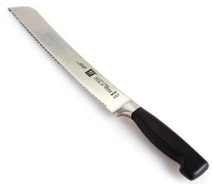    Have learners identify materials used for making kitchen tools and equipment.  Example: Aluminum, tins, etc.  In a matching game, let learners match tools to their uses.  Assessment  Mention any three each of cutting and molding tools used in the kitchen. |  |  |  | Pictures of knives, biscuit cutters, Cake tins, moulds, scoops for ice cream etc
PHASE 3: REFLECTION | Use peer discussion and effective questioning to find out from learners what they have learnt during the lesson.  Take feedback from learners and summarize the lesson.

Week Ending: |  | Period: |  | Subject: Career Technology
Duration: |  |  |  | Strand: Tools, Equipment & Processes
Class: B7 |  | Class Size: |  | Sub Strand: Cutting/Shaping
Content Standard:  B7.3.2.1 Demonstrate understanding of cutting/shaping tools and equipment for production |  |  | Indicator:  B7.3.2.1.1: Identify cutting and shaping tools and equipment used for production |  | Lesson:
Performance Indicator:  Learners can identify cutting and shaping tools and equipment in the sewing laboratory |  |  |  | Core Competencies:  CP6.5: Ability to select alternatives that adequately meet selected criteria
Reference: Career Technology Curriculum Pg. 19
Phase/Duration | Learners Activities |  |  |  |  | Resources
PHASE 1: STARTER | Revise with learners to find out what they already know about cutting and shaping tools in the Food laboratory.  Introduce the lesson by sharing the performance indicators.
PHASE 2: NEW LEARNING | Guide learners to identify from displayed realia or pictures, tools and equipment used for cutting and shaping in the sewing laboratory  Example: Scissors, pinking shears, seam ripper and French curves) etc.  Guide learners to identify and classify the types of cutting and shaping tools and equipment in the sewing laboratory.  Example: Scissors, seam ripper, etc.  Have learners to identify the uses of each tool and equipment found in sewing laboratory:  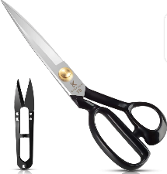  Have learners identify materials used for making sewing tools and equipment.  Example: Aluminum, wood, etc.  In a matching game, let learners match tools to their uses.  Assessment  Mention any three each of cutting tools used in the sewing laboratory. |  |  |  |  | identify and describe the different types of catering tools and equipment
PHASE 3: REFLECTION | Use peer discussion and effective questioning to find out from learners what they have learnt during the lesson.  Take feedback from learners and summarize the lesson.

Week Ending: |  | Period: |  | Subject: Career Technology
Duration: |  |  |  | Strand: Tools, Equipment & Processes
Class: B7 |  | Class Size: |  | Sub Strand: Cutting/Shaping
Content Standard:  B7.3.2.1 Demonstrate understanding of cutting/shaping tools and equipment for production |  |  | Indicator:  B7.3.2.1.1: Identify cutting and shaping tools and equipment used for production |  |  | Lesson:
Performance Indicator:  Learners can identify cutting and shaping tools and equipment in the wood workshop. |  |  |  | Core Competencies:  CP6.5: Ability to select alternatives that adequately meet selected criteria
Reference: Career Technology Curriculum Pg. 19
Phase/Duration | Learners Activities |  |  |  | Resources
PHASE 1: STARTER | Revise with learners to find out what they already know about cutting and shaping tools in the Food laboratory.  Introduce the lesson by sharing the performance indicators.
PHASE 2: NEW LEARNING | Guide learners to identify from displayed realia or pictures, tools and equipment used for cutting and shaping in the wood workshop.  Example: Rip saws, cross cut saw, tenon saw, firmer chisel, mortise chisel, spoke shave, rasp file etc.  Guide learners to identify and classify the types of cutting and shaping tools and equipment in the wood workshop.  Example: Rip saws, cross cut saw, etc.  Have learners to identify the uses of each tool and equipment found in wood workshop:  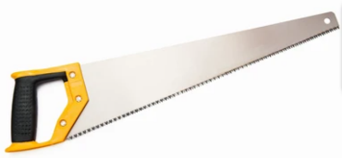  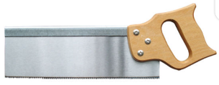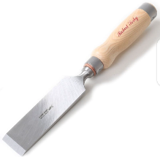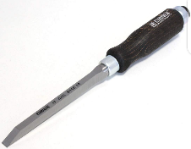  Have learners identify materials used for making tools and equipment in the wood workshop.  Example: Aluminum, wood, etc.  In a matching game, let learners match tools to their uses.  Assessment  Mention any three each of cutting tools used in the wood workshop. |  |  |  | identify and describe the different types of catering tools and equipment
PHASE 3: REFLECTION | Use peer discussion and effective questioning to find out from learners what they have learnt during the lesson.  Take feedback from learners and summarize the lesson.

